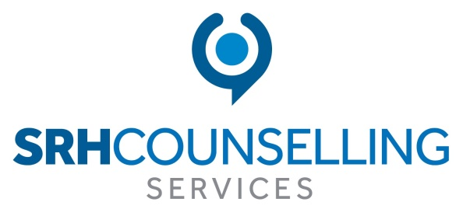

Training Schedule Spring/Summer2020

Susan Harvey
Counsellor, Supervisor, Trainer

CPD Training and Workshop Program 2020
This is a program of half, one and two-day events which are suitable for qualified counsellors, student counsellors, health and education professionals and interested members of the public.
All events are theory led and will cover a range of psychological issues. The two day events will comprise of theory and skills and give targeted interventions for working with the issues presented.
All events are taught in an informal, small group style. The training is designed to be interactive between the trainer and trainees and for this reason numbers are restricted to a maximum of 24 persons for all half and one day events and 18 persons for all 2-day events (this lower number is due to the skills aspect of the training).
Concessions are available for advance booking and if the attendees are students/low income (see booking form for more information).
Certification of attendance at all events will be provided.
Refreshments are provided at each event. Lunch is only provided at full day events. Please advise if you have any dietary requirements.

Places on each workshop will only be confirmed once payment has been received. Places will be held provisionally for 7 days to allow for those paying by cheque or bank transfer.

Cancellation Policy: Workshops cancelled less than 10 days prior to the event cannot be refunded. You can offer the place to a friend or move your place to another workshop of similar duration.

Course materials will be emailed to each attendee after the event.
Spring and Summer Events

Workshop Title | Date & Time
Understanding Addiction from a Psychodynamic Perspective | Saturday 8th& Sunday 9th February  10-4pm each day
Emotional Avoidance: An Attachment Perspective | Saturday 22nd February  9.30-12.30pm
Setting Up and Running a Private Counselling Practice | Saturday 22nd February  2.15-5.15pm
When It’s All About them: Narcissism and Relationships | Saturday 14th March 9.30-12.30pm
Who Am I? Understanding Co-Dependency as the Disease of the Lost Self | Saturday 14th March 2.15-5.15pm
Understanding the Language of Self Harm | Saturday 25th April 10am-4.15pm
The Haunted Self: Understanding Dissociation | Sunday 26th April 9.30-12.30pm
Understanding the Complexity of Perfectionism | Sunday 26th April 2.15-5.15pm
Understanding and Working with Sexual Abuse | Saturday 30th & Sunday 31st May 10-4pm each day
Compulsive Hoarding | Saturday 27th June 9.30-12.30pm
Emotional Suffocation | Saturday 27th June 2.15-5.15pm
Working Creatively with Adult Clients | Sunday 28th June 9.30-12.30
Grudges: Letting Go of Bitterness | Sunday 28th June 2.15-5.15pm
Registration opens 30 minutes before the listed start time
Understanding Addiction from a Psychodynamic Perspective
Saturday 8th & Sunday 9th February
Two Day Workshop 10-4pm each day
The Holiday Inn Express 106 University Street Belfast
This workshop aims to give a better understanding of addiction leading to greater clarity on the issues of impulse control, compulsion and choice. Explored from a Psychodynamic perspective this 2-day workshop will explore substance and behavioural addictions-gambling, sex, internet and food within the theories of Attachment, Object Relations and Drives. It will incorporate skills- based interventions for working with addictions.
Susan Harvey has been a practising counsellor for 23years. She has worked continuously for 19 years in the field of addiction. Susan is also an experienced supervisor and lecturer.
Cost £110 (concessions apply) price includes refreshments and a light lunch.
Please contact Susan Harvey for more information at
srhcounsellingservices@gmail.com or on 07759615143

Emotional Avoidance:
An Attachment Perspective
Half Day Workshop

Saturday 22nd February 9.30-12.30pm

The Holiday Inn Express 106 University Street Belfast
Emotional avoidance is an adapted coping strategy to control and minimise the risk of rejection from others. The suppression of emotion leads to the creation of a façade and with it shame and fear. Explored from a Psychodynamic perspective this workshop will explore when emotional avoidance becomes pathological leading to psychological withdrawal, the loss of self and shame-based rage and violence.
Susan Harvey has been a praticising counsellor for 23 years and works with children, teens, adults, couples and families. Susan is also an experienced supervisor and lecturer.

Cost £35 (Concessions apply) this includes refreshments.
Please contact Susan Harvey for more information at
srhcounsellingservices@gmail.com or on 07759615143

Setting Up and Running a Private Counselling Practice

Half Day Workshop

Saturday 22nd February 2020 2.15-5.15pm

The Holiday Inn Express 106 University Street Belfast

Have you ever wanted to set up your own counselling practice but feel daunted and overwhelmed by the prospect? This workshop will examine the initial start-up issues, how to build your practice and pitfalls that can be avoided.

Susan has been a practising counsellor for 23 years and runs a successful private practice in South Belfast. Susan is also and experienced supervisor and lecturer.

Cost £35 (concessions apply) this includes refreshments.

Please contact Susan Harvey for more information at
srhcounsellingservices@gmail.com or on 07759615143

When it’s all About Them:
Narcissism and Relationships

Half Day Workshop
Saturday 14th March 2020 9.30-12.30pm

The Holiday Inn Express 106 University Street Belfast

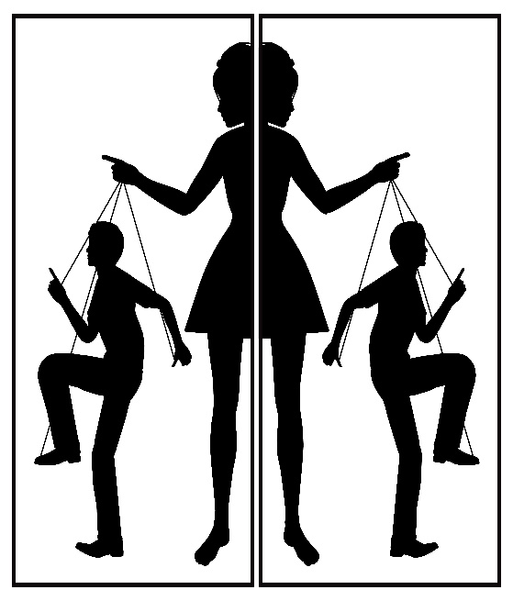
This workshop aims to explore the psychological dynamics in relationships when one party displays narcissistic tendencies. Familial, friendship and intimate partner relationships will be examined. Exhibitionist, Closet and Malignant narcissism will be explored and how these presentations manifest in relationships.
Susan Harvey has been a practising counsellor for 23 years. She has worked with narcissism throughout her career presented as adult children of narcissists, partners and families and clients with a Narcissistic Personality Disorder. Susan is also an experienced supervisor and lecturer.

Cost £35 (concessions apply) this includes refreshments.
Please contact Susan Harvey for more information at
srhcounsellingservices@gmail.com or on 07759615143
Who am I?
Understanding Co-Dependency as the Disease of the Lost Self
Half Day Workshop
Saturday 14th March 2.15-5.15pm
The Holiday Inn Express 106 University Street Belfast
Explored from a Psychodynamic Perspective this workshop will focus on the nature of co-dependency and the dysfunctional helping relationship of “enabling” which is underpinned by the individual’s loss of identity and the co-dependant’s insatiable need for approval from others.
Susan Harvey has been a practising counsellor for 23years. She has worked continuously for 18 years in the field of addiction. Susan is also an experienced supervisor and lecturer.
Cost £65(concessions apply) this includes refreshments and a light lunch.

Please contact Susan Harvey for more information at
srhcounsellingservices@gmail.com or on 07759615143
Understanding the Language
of Self Harm
One Day Workshop
Saturday 25th April 2020 10am-4.15pm
The Holiday Inn Express 106 University Street Belfast
This workshop will address the trauma of this psychological disorder of self-mutilation. We will examine the predisposing risk factors of genetics, family dynamics, and childhood trauma will be explored from a psychodynamic perspective.
Susan Harvey has been a praticising counsellor for 23 years and has worked continuously with self-harm and suicidology at a community and statutory level. Susan is also an experienced supervisor and lecturer.
Cost £65 (concessions apply) this includes refreshments and a light lunch.
Please contact Susan Harvey for more information at
srhcounsellingservices@gmail.com or on 07759615143

The Haunted Self: Understanding Dissociation
Half day Workshop: Sunday 26th April 9.30-12.30pm
The Holiday Inn Express 106 University Street Belfast
“It’s so much safer not to feel, not to let the world touch me” Sylvia Plath.
Dissociation is a mental process where a person disconnects from their thoughts, feelings, memories or sense of identity. Explored from a psychodynamic perspective this workshop will examine this frequently misunderstood defence mechanism.

Susan Harvey has been a praticising counsellor for 23 years and has worked continuously with complex and challenging Tier 3&4 mental health. Susan is also an experienced supervisor and lecturer.

Cost £35 (concessions apply) this includes refreshments
Please contact Susan Harvey for more information at:
srhcounsellingservices@gmail.com or on 07759615143

Understanding the Complexity of Perfectionism
Half Day Workshop: Sunday 26th April 2.30-5.30 pm
The Holiday Inn Express 106 University Street Belfast

Perfectionism, is a personality trait characterised by a person's striving for flawlessness and setting high performance standards, accompanied by critical self-evaluations and concerns regarding others' evaluations. Explored from a Psychodynamic Perspective this workshop will explore the complex nature of perfectionism, and the drives behind this façade

Susan Harvey has been a praticising counsellor for 23 years and has worked continuously with complex and challenging Tier 3&4 mental health. Susan is also an experienced supervisor and lecturer.

Cost £35(concessions apply) this includes refreshments. Please contact Susan Harvey for more information at: srhcounsellingservices@gmail.com or on 07759615143

Understanding and Working with Survivors of Sexual Abuse
Saturday 30th & Sunday 31st May 10-4pm each day
The Holiday Inn Express 106 University Street Belfast
Day 1: This workshop will explore the psychological cycle of abuse and the impact upon the survivors and their families.
Day 2: Theory and skills will be taught to enable therapists to have a ‘tool kit’ of interventions to enable the survivor to reconnect with ‘their self’ and with others.
Susan Harvey has been a practising counsellor for 23 years. She has worked continuously with survivors of abuse and their families. Susan is also an experienced supervisor and lecturer.

Cost: £110 (concessions apply) this includes refreshments and a light lunch on each day.

Please contact Susan Harvey for more information at srhcounsellingservices@gmail.com or on 07759615143

Compulsive Hoarding:
When our Precious Things Become our Jailors
Half Day Event Saturday 27th June 9.30-12.30pm
The Holiday Inn Express 106 University St Belfast
Compulsive Hoarding impairs a person’s ability to function, alienates them from others and perpetuates a state of helplessness and shame. A condition that is widely misunderstood and often receives ridicule and judgement.
This workshop aims to explore this condition from a Psychodynamic Perspective, shedding light on its complexity and gaining an understanding of its origins in attachment and object relations.
Susan Harvey has been a praticising counsellor for 23 years and has worked continuously with complex and challenging Tier 3&4 mental health. Susan is also an experienced supervisor and lecturer.

Cost £35(concessions apply) this includes refreshments.
Please contact Susan Harvey for more information: srhcounsellingservices@gmail.com or on 07759615143

Suffocated by Love and Need.
An Attachment Perspective
Half Day Event
Saturday 27th June 2.15-5.15pm
The Holiday Inn Express 106 University St Belfast
An Emotionally suffocating relationship is one where one of the parties is putting most, if not all their emotional, relational and socialising needs onto their partner, causing the partner to feel trapped and manipulated.
Explored from a Psychodynamic perspective this workshop will explore when our need for others grows into emotional dependency and becomes pathological. Leading to the psychological loss of self, shame and intimate partner violence and suicide.
Susan Harvey has been a praticising counsellor for 23 years and works with children, teens, adults, couples and families. Susan is also an experienced supervisor and lecturer.
Cost £35(concessions apply) this includes refreshments.
Please contact Susan Harvey for more information: srhcounsellingservices@gmail.com or on 07759615143
Working Creatively with Adult Clients

Half Day Workshop
Sunday 28th June 9.30-12.30

The Holiday Inn Express 106 University Street Belfast
The creative process in arts, music, writing or crafting, can open us up to new aspects of ourselves; parts hidden and concealed through convention and fear. Thoughts, dreams, imaginings can all be explored non-verbally in a therapeutic setting to enable us to self-heal. This workshop is an introduction to how we can creatively introduce and use creative mediums in our adult client work.

Susan Harvey has been a practising counsellor for 22 years and uses creative mediums with clients of all ages. She is also an experienced supervisor and lecturer.

Cost £35 (concessions apply) this includes refreshments.

Please contact Susan Harvey for more information at
srhcounsellingservices@gmail.com or on 07759615143

Grudges: Letting Go of Bitterness
Half Day Workshop
Sunday 28th June 2020 2.15pm-5.15pm
The Holiday Inn Express 106 University St Belfast

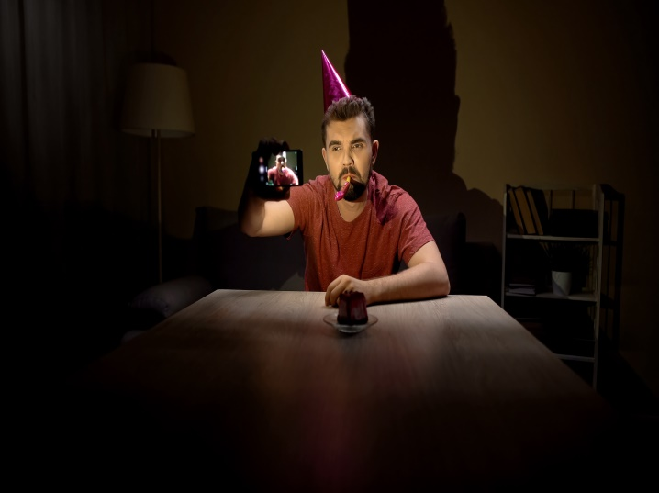
Grudges are not restricted by gender, age, class or ethnicity. We have all known grudges; by holding them ourselves, knowing someone who has held one or have been on the receiving end of a person’s grudge. Grudges can be deep and last a lifetime. This workshop will explore from a psychodynamic perspective why we choose to keep wounds open and active, choosing to live in the past. What keeps us stuck when we actually want to move on and be free?
Susan Harvey has been a praticising counsellor for 23 years and works with children, teens, adults, couples and families. Susan is also an experienced supervisor and lecturer.

Cost £35 (Concessions apply) this includes refreshments.
Please contact Susan Harvey for more information at
srhcounsellingservices@gmail.com or on 07759615143
BOOKING FORM
Name:
Address:
Email:
Phone:
Date | Course Title | Full Price | Discount | Cost
Example:  8&9 Sept | Working Therapeutically With Children | £110 | 20% | £88
Total Cost to be Paid:
Discounts
Save 10% with Early Bird Booking: book any event 4 weeks in advance
Save 10% if you are a student, low waged, unwaged or retired
Book 4 events and select a ‘half- day’ event FREE
Payment
Cheque: Made payable to SRH Counselling Services and post to SRH Counselling Services, 56 University Street Belfast BT7 1HB
PayPal: enter paypal.me/SRHCounselling/ into a google search then when displayed enter the amount you wish to pay
Online Banking: Sort Code: 09-01-29 Account Number: 11183415

